Stage 4 ★★★
Mixed Selection 1 - Solutions

- Symmetric angles
As the figure has rotational symmetry of order 4, $ABEF$ is a square.
Area $ABEF=4×$ area of $△BDA=4×\frac{1}{2}BD×DA=2{\left(BD\right)}^{2}=24\text{c}{\text{m}}^{\text{2}}$, so $BD=\sqrt{12}cm=2\sqrt{3}cm$.
As $ABEF$ is a square, $∠ABD=45°$ so $∠CBD=45°-15°=30°$.
Since $\tan{30°}=\frac{CD}{BD}=\frac{CD}{2\sqrt{3}}$, we have $CD=2\sqrt{3}\tan{30}\text{cm}$.
Now consider the following equilateral triangle with side lengths 2:

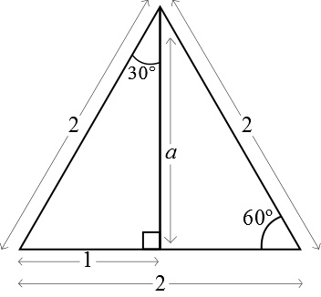
The vertical line is perpendicular to the base-line and so bisects both the angle at the top vertex and the base-line. Consider the left right-angled triangle. Pythagoras' theorem gives $a= \sqrt{3}$ and then we have
$\tan{30}=\frac{1}{a}=\frac{1}{\sqrt{3}}$.
Therefore $CD=2\sqrt{3} \text{tan}30=2\text{cm}$.

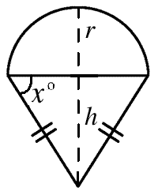
- Ice cream tangent
Let the radius of the circle be $r$ and let the perpendicular height of the triangle be $h$. Then
$$\tan{x}=\frac{h}{r}$$
Now, the area of the semicircle is $\frac{1}{2}πr^{2}$ and the area of the triangle is $\frac{1}{2}×2r×h$. This gives $rh =\frac{ 1}{2}πr^{2}$, so $\frac{h}{r}=\frac{π}{2}$ .

- Overlapping ribbons
In this diagram, the length and perpendicular ‘height’ of the parallelogram formed by the overlap are marked in red, and a helpful triangle is coloured yellow.
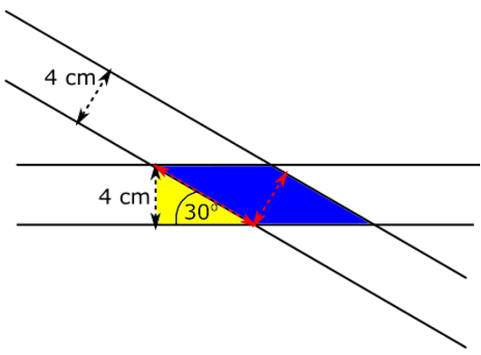
The ‘height’ of the parallelogram is 4 cm and the length of the parallelogram is equal to the hypotenuse of the yellow triangle. This hypotenuse can be found using trigonometry.
$$sin⁡(30)=4\text{hyp}⟹\sin\left(30\right)×\text{hyp}=4⟹\text{hyp}=4sin⁡(30)=8$$So the length of the parallelogram is 8 cm and its ‘height’ is 4 cm, so its area is $8×4 = 32 cm^{2}$.
A fuller solution is available at: https://nrich.maths.org/12761/solution

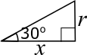
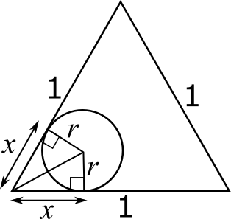
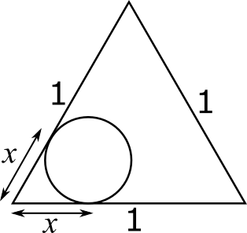
- The roller and the triangle
The circle won't fit into the corners of the triangle, so it won't touch some of the parts of the perimeter of the triangle. The parts that it won't touch are the parts that Clare can't paint with the roller, and they are labelled $x$ on the diagram.
Using the radius of the circle, two right-angled triangles can be made which contain $x$, as shown below (they are right-angled because the angle between the tangent and the radius is ${90}^{o}$).
The radius of the circle can be found using the formula circumference = $π×2r$, so $1=2πr$, so $r=\frac{1}{2π}$.
We can use trigonometry to find out the unknown length $x$. Since the two right-angled triangles drawn share all three sides, they are congruent, so the ${60}^{o}$ angle of the triangle must be bisected to give two ${30}^{o}$ angles.
This gives the triangle shown. $tan⁡(30)=\frac{r}{x}$, and since $r=\frac{1}{2π}$ and $tan⁡(30)=\frac{1}{\sqrt{3}}$, we get that:$$\frac{1}{\sqrt{3} }=\frac{\frac{1}{2π}}{x}⇒\frac{x}{\sqrt{3}}=\frac{1}{2π}⇒x=\frac{\sqrt{3}}{2π}$$So the circle will touch all of the perimeter of the triangle, which is 3, except for $x$ twice at each corner. So the circle will touch $3-6x=3-6\left(\frac{\sqrt{3}}{2π}\right)=3-\frac{3\sqrt{3}}{π}$.
A fuller solution is available at: https://nrich.maths.org/12788/solution

